PRESS RELEASE JDN109

NICKEL PLATED HOISTS SUITABLE FOR
HYGIENICALLY CRITICAL AREAS

Selected models from the J D Neuhaus range of air operated hoists and trolleys are now available for clean room operations and other specialist applications that also require hygienic working conditions. These include chemical and pharmaceutical production establishments, together with the food and drink industries covering all aspects of both handling and manufacture.

With a plating thickness of 25 µm, the hoists ensure resistance to environmental humidity as well as providing a good general corrosion resistance. The typical component parts of the hoist units that are subject to the nickel plating process include the lift/lower motor together with gearbox and the main centrepiece body. Where the hoist is trolley mounted for overhead rail operation, the trolley body and both driving and traverse motors are also nickel-plated.

Further protective features also available include the provision of stainless steel options for the top suspension hook, both the load hook and sleeve, together with the lift/lower chain mechanisms and 12 metre capacity chain bag. Specification of the stainless steel hook and chain does limit the lift capacity to 750kg however. Further options include plastic chain boxes suitable for 3, 6 and 12 metre chain lengths together with a 12 metre galvanised chain box.

Continued ……
A further positive aspect of the products is the fact that the lift motor does not require lubrication and all hoists are classified as explosion protected to comply with Directive 2014/34/EU [Equipment & Protective Systems Intended for use in Potentially Explosive areas (ATEX)]. The hoists are also classified as capable of 100% duty rating with no downtimes.

The models currently available in the nickel-plated range include: the Profi TI hoists with 0.5 and 1 tonne lift capacities, together with a big-bag handling unit with a rated 1 tonne lift. A low headroom trolley hoist of 1 tonne capacity is also available, which is designed for operation in areas subject to low headroom capacity. Where Profi hoists are utilised with trolleys for overhead rail mounting, both manual operated (type LN) and motorised (type LM) trolleys can be provided which have also been subject to appropriate nickel-plating treatment for use in hygienically critical areas.

Further information is available on request to:
J D Neuhaus GmbH & Co. KG, 58449, Witten-Heven, Germany
Telephone: +49 2302 208-219 Fax: +49 2302 208-286
e-mail: info@jdngroup.com www.jdngroup.com

Worldwide contact details for J D Neuhaus can be seen at the end of this press release.

facebook.com/jdneuhaus www.jdngroup.com/plus

(approximately 400 words
including photographic annotation)

Continued ……

General Information

Supplier: J. D. Neuhaus GmbH & Co. KG

Press Release No: JDN109

Press or publishing inquiries to: Steve Lloyd
Enterprise Marketing Services Ltd
The Coach House, 1 Dunstall Road, Barton under Needwood,
Burton on Trent, Staffordshire, DE13 8AX, UK
Tel: +44 (0) 1283 713185
Fax: +44 (0) 1283 716172
e-mail: info@enterprise-marketing.co.uk

Reader response inquiries to: Mr Manfred Müller of J D Neuhaus GmbH & Co. KG

Downloads: The press release text (MS Word and PDF format) and image are
available for download at:

www.enterprise-marketing.co.uk/jdn/jdn109.html

Our Reference: JDN109/16/08/V2

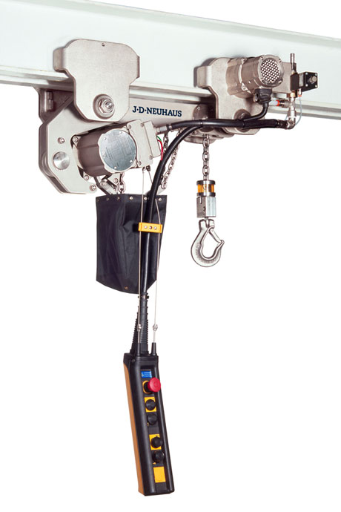
A nickel plated hoist from J D Neuhaus, suitable for use within hygienically critical areas.
Download high resolution 300dpi image (1800 x 2700 px)
Download low resolution 72dpi image (600 x 900 px)

Continued ……
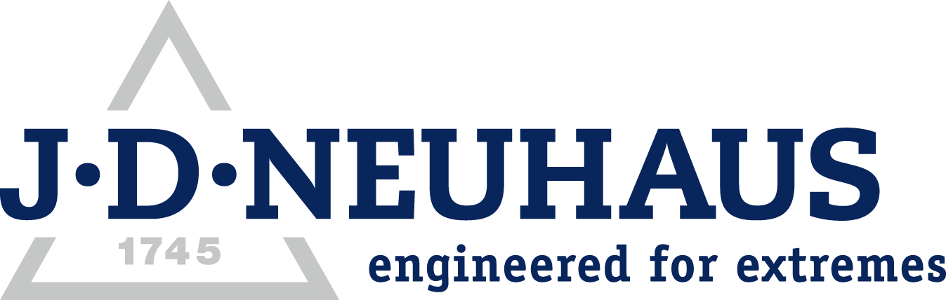
Company information

J D Neuhaus are a privately-owned company, founded in 1745, and for over 270 years they have been using their expertise and experience to manufacture the highest quality hoists and cranes.

Their products offer solutions to almost every material handling problem irrespective of the driving medium: from air and hydraulic hoists up to complete crane installations with explosion proofness.

JDN products are used in a wide variety of industries including:
Airplane Yards; Atomic/Coal Power Stations; Big Bag Handling; Cement Industry; Chemical Industry;
Crane Manufacturers; Dairies; Food Industry; Foundries; Galvanisation; Glass/Ceramics; Large Kitchens;
Leather Plants; Locks; Machine and Plant Construction; Mining; Motor Car Industry; Offshore/Onshore;
Oil Storage; Over/Underground Construction; Paints and Varnish; Painting and Coating Installations;
Paper Industry; Pharmaceutical Industry; Printing Industry; Pyrotechnics Industries; Refineries; Sawmills; Shipbuilding and Shiprepair Yards; Ships; Space Technique; Spray Booths; Steel Works; Surface Technique;
Tank Cleaning Devices; Textile Industry; Tunnel; Tyre Manufacturers; Vacuum Technique

Contact J D Neuhaus

J D Neuhaus are represented in more than 90 countries and over 70 branches Worldwide.

Germany
J D Neuhaus GmbH & Co. KG, 58449, Witten-Heven, Germany
Tel: +49 2302 208-219 Fax: +49 2302 208-286
e-mail: info@jdngroup.com www.jdngroup.com

France
J D Neuhaus S.A.R.L., 24, rue du Président Krüger, 69008, Lyon, France
Tel: +33 4 3790-1745 Fax: +33 4 3790-1746
e-mail: info@jdneuhaus.fr www.jdngroup.com

Great Britain
J D Neuhaus Ltd, Unit 6 Kirkton Avenue, Pitmedden Road Industrial Estate, Dyce, Aberdeen, AB21 0BF, UK
Tel: +44 1224 722751 Fax: +44 1224 729895
e-mail: info@jdneuhaus.co.uk www.jdngroup.com

Singapore
J.D. Neuhaus Pte. Ltd, 21 Toh Guan Road East, #09-02 Toh Guan Centre, 608609, Singapore
Tel: +65 62758911 Fax: +65 62758922
e-mail: info@jdn.com.sg www.jdngroup.com

USA
J.D. Neuhaus L.P., 9 Loveton Circle, MD 21152 Sparks, USA
Tel: +1-410 472-0500 Fax: +1-410 472-2202
e-mail: info@jdneuhaus.com www.jdngroup.com

